RIPE NCC

🌐 What Is RIPE NCC?
# Source: AI Source: Provided by: [Data Path: Persons Table -> ID Column: 1, Name_En Column: Motasem Essam] -> From: [ChatGPT] on [1/16/2026]
RIPE NCC stands for Réseaux IP Européens Network Coordination Centre. It is one of the five Regional Internet Registries (RIRs) and is responsible for allocating and managing:
- IP address space (IPv4 & IPv6)
- Autonomous System Numbers (ASNs)
…in Europe, the Middle East, and parts of Central Asia.

🧠 Simple Definition:
# Source: AI Source: Provided by: [Data Path: Persons Table -> ID Column: 1, Name_En Column: Motasem Essam] -> From: [ChatGPT] on [1/16/2026]
RIPE NCC is the nonprofit organization that hands out IP addresses and AS numbers to ISPs, companies, and governments in Europe and nearby regions.

🌎 RIPE NCC Region Includes:
# Source: AI Source: Provided by: [Data Path: Persons Table -> ID Column: 1, Name_En Column: Motasem Essam] -> From: [ChatGPT] on [1/16/2026]
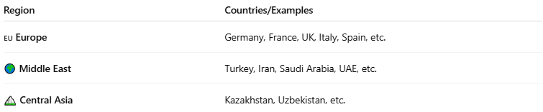

Region | Countries/Examples
🇪🇺 Europe | Germany, France, UK, Italy, Spain, etc.
🌍 Middle East | Turkey, Iran, Saudi Arabia, UAE, etc.
🏔️ Central Asia | Kazakhstan, Uzbekistan, etc.

🔧 RIPE NCC’s Key Responsibilities
# Source: AI Source: Provided by: [Data Path: Persons Table -> ID Column: 1, Name_En Column: Motasem Essam] -> From: [ChatGPT] on [1/16/2026]
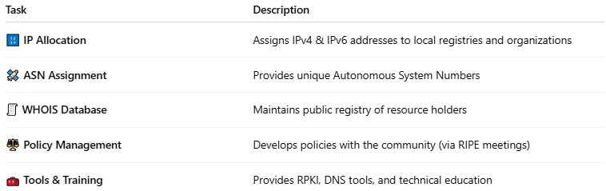

Task | Description
🔢 IP Allocation | Assigns IPv4 & IPv6 addresses to local registries and organizations
🛰 ASN Assignment | Provides unique Autonomous System Numbers
🧾 WHOIS Database | Maintains public registry of resource holders
⚖️ Policy Management | Develops policies with the community (via RIPE meetings)
🧰 Tools & Training | Provides RPKI, DNS tools, and technical education

🧠 What is RIPE?
# Source: AI Source: Provided by: [Data Path: Persons Table -> ID Column: 1, Name_En Column: Motasem Essam] -> From: [ChatGPT] on [1/16/2026]
- RIPE (Réseaux IP Européens) is the open community of internet stakeholders who develop policies.
- RIPE NCC is the secretariat (operations body) that carries out the technical work based on RIPE’s policies.
RIPE = The community
RIPE NCC = The organization that supports and implements

🧾 WHOIS Example (RIPE NCC)
# Source: AI Source: Provided by: [Data Path: Persons Table -> ID Column: 1, Name_En Column: Motasem Essam] -> From: [ChatGPT] on [1/16/2026]
Looking up IP 193.0.0.0 (owned by RIPE NCC):
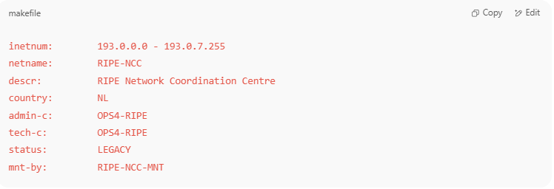
inetnum: 193.0.0.0 - 193.0.7.255
netname: RIPE-NCC
descr: RIPE Network Coordination Centre
country: NL
admin-c: OPS4-RIPE
tech-c: OPS4-RIPE
status: LEGACY
mnt-by: RIPE-NCC-MNT

✅ Summary
# Source: AI Source: Provided by: [Data Path: Persons Table -> ID Column: 1, Name_En Column: Motasem Essam] -> From: [ChatGPT] on [1/16/2026]
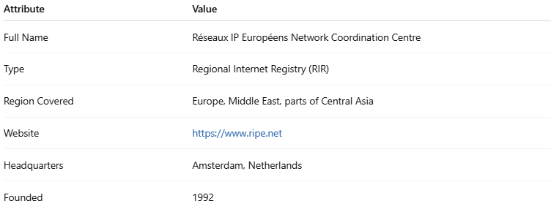

Attribute | Value
Full Name | Réseaux IP Européens Network Coordination Centre
Type | Regional Internet Registry (RIR)
Region Covered | Europe, Middle East, parts of Central Asia
Website | https://www.ripe.net
Headquarters | Amsterdam, Netherlands
Founded | 1992

